**REPRODUCTIVE SYSTEMS**

**TODAY’S GOALS:**

Describe three functions of the male reproductive system.

Describe three functions of the female reproductive system.

Identify parts of the male and female reproductive systems.

Summarize the stages of the menstrual cycle.

Summarize the pathway of the sperm.

**National Standards:**

10.1.12 Evaluate factors that impact growth and development

during adulthood and late adulthood. (Relationships)

**MCj02906790000[1]**

1. _______________________________
2. _______________________________
3. __________________________________________________

**MALE REPRODUCTIVE SYSTEM**

|  |  |
| --- | --- |
|  | External sexual organ through which sperm leave the body |
|  | Sac of skin carrying the testes |
|  | Loose skin covering the penis |
|  | Tube used to transfer sperm to the seminal vesicles |
|  | Adds fluid that protects the sperm |
|  | Male Reproductive Glands  2 major functions: Produce Testosterone and Produce Sperm. |
|  | Add a fluid that provides a source of energy for active sperm |
|  | A tube that passes through the penis to the outside of the body |
|  | Produce fluid that protects sperm from acidic conditions in the urethra |
|  | The ejection of semen from the penis |
|  | The sexual climax |
|  | An ejaculation during sleep; also called a wet dream. |
|  | The touching of one’s own genitals for sexual pleasure |

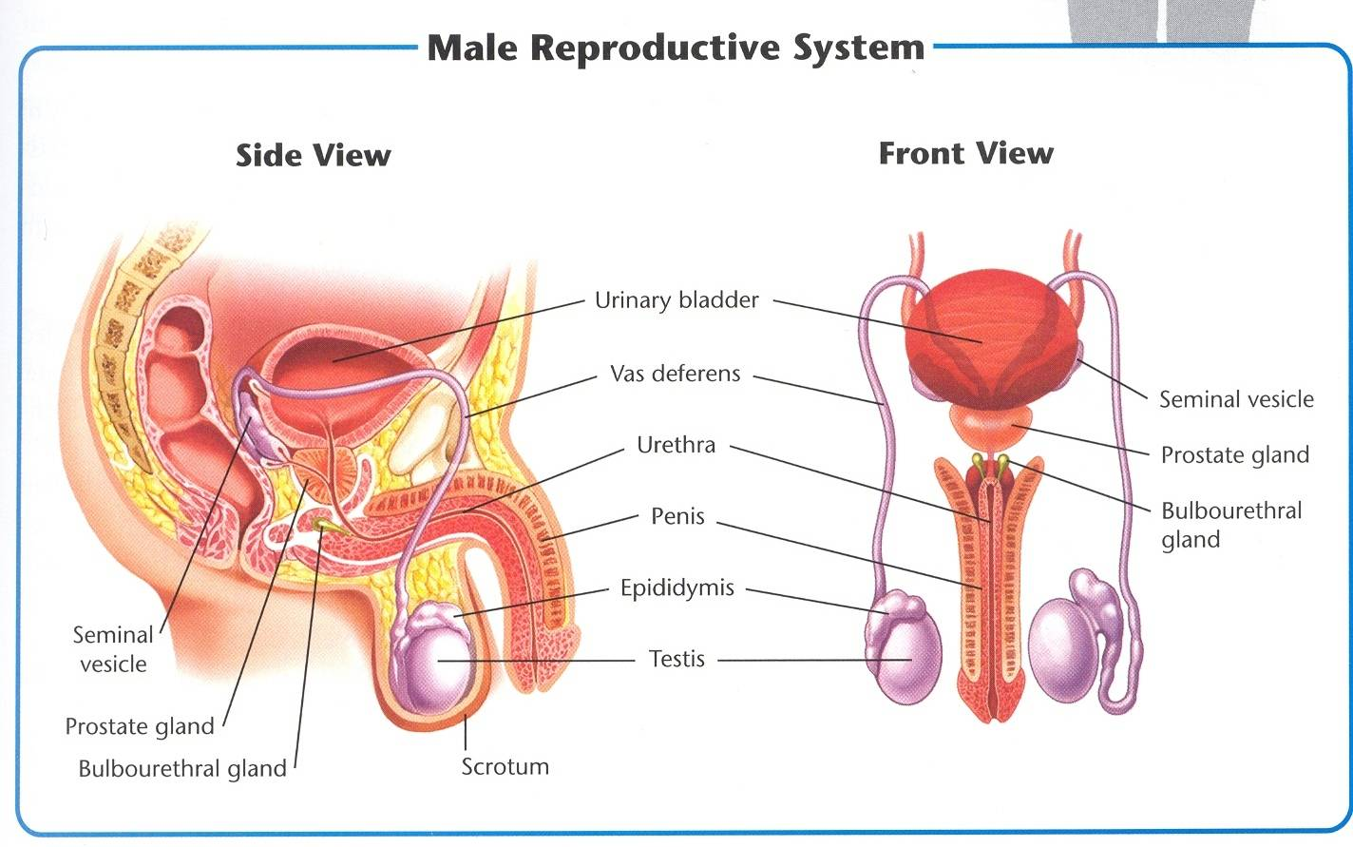

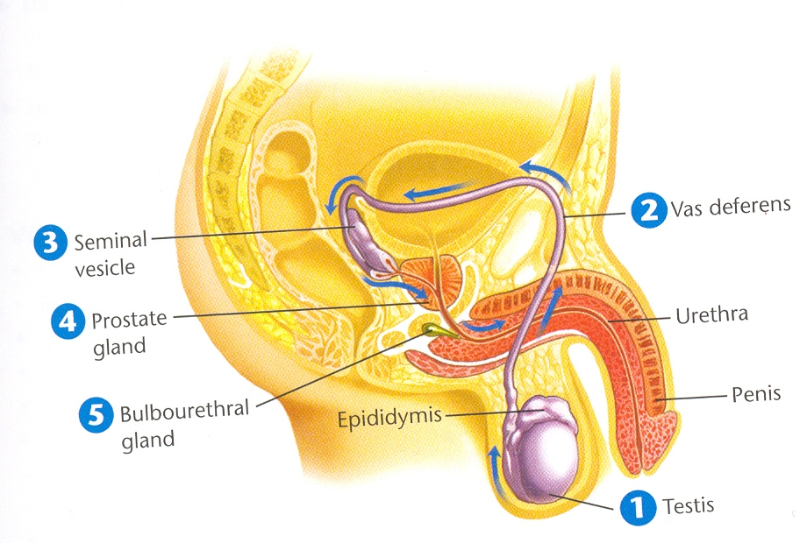

1. Sperm are produced _________________. They mature and are stored in the epididymis.
2. Sperm travel through _______________________ to the seminal vesicle.
3. Seminal vesicles add __________________________ ________________________to the active sperm.
4. The prostate gland adds a fluid that protects the ___________.
5. The bulbourethral glands add a fluid that protects sperm from _____________________ in the urethra.

Caring for the male reproductive system involves the following:

|  |
| --- |
| **Cleanliness**  Showering can prevent fungal infections that cause jock itch |
| **Sexual Abstinence**  Many serious infections can result from sexual contact, practice sexual abstinence |
| **Protection from Trauma**  During athletic activities males should wear a cup  Tight clothes should be avoided (can cause irritation)  Be careful lifting heavy objects, can cause a hernia (intestines pushed into abdomen)  **Testicular Torsion: very serious**  Is a twisting of the testis and blood vessels cutting off blood supply  This is a medical emergency and must be untwisted in surgery within 6 hours  to keep testes alive |
| **Self-Exams**  Important to monitor their bodies for possible medical problems.  Painful urination, unusual discharge or sores require a medical exam  Examine for signs of **Testicular Cancer** (especially teens and young adults)  Testicular cancer is the most common type of cancers in males ages 15-34  Learn how to perform a self-exam |
| **Medical Checkups**  This is the time to bring up questions or ask out of curiosity  Men aged 50 are encouraged to get screened for **Prostate Cancer**  An enlarged prostate may cause painful or difficult urination  Infertility is a condition where you can reproduce |

**FEMALE REPRODUCTIVE SYSTEM**

|  |  |
| --- | --- |
|  | The female reproductive glands |
|  | The passageways that carry eggs from the ovaries to the uterus |
|  | The hollow, muscular, pear-shaped organ in which a fertilized egg develops and grows. |
|  | The narrow base of the uterus. |
|  | The hollow, muscular passage leading from the uterus to the outside of the female body. |
|  | The reproductive cells in females. Eggs. |
|  | The process during which an ovary releases a mature egg that travels to the uterus; if the egg is not fertilized, the uterine lining is shed and a new cycle begins. |

1. ______________________________
2. ______________________________
3. Provide a nourishing environment in which a fertilized egg can develop into a fetus.

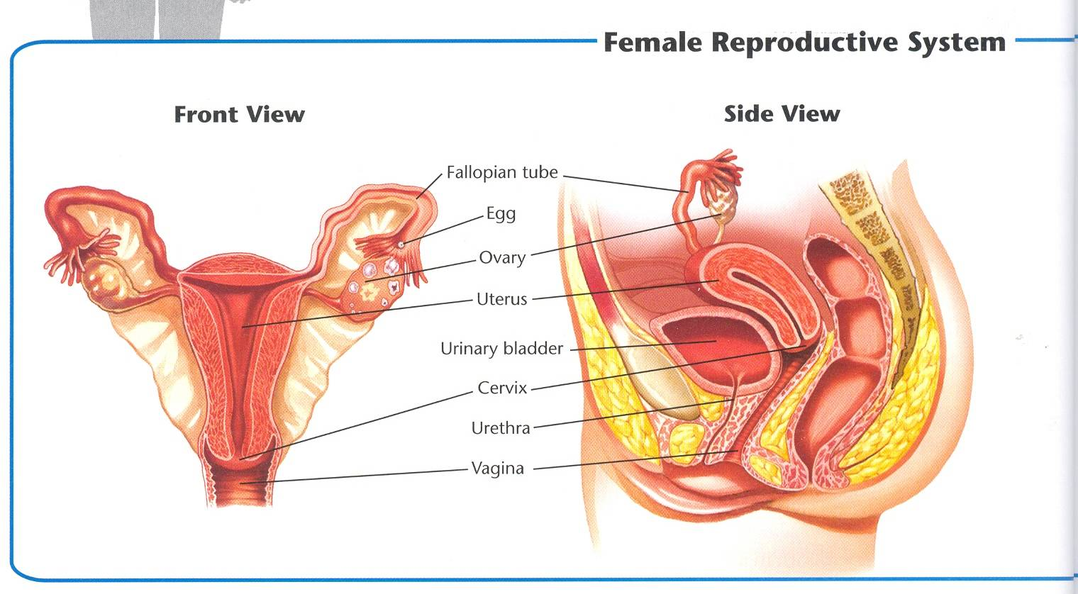

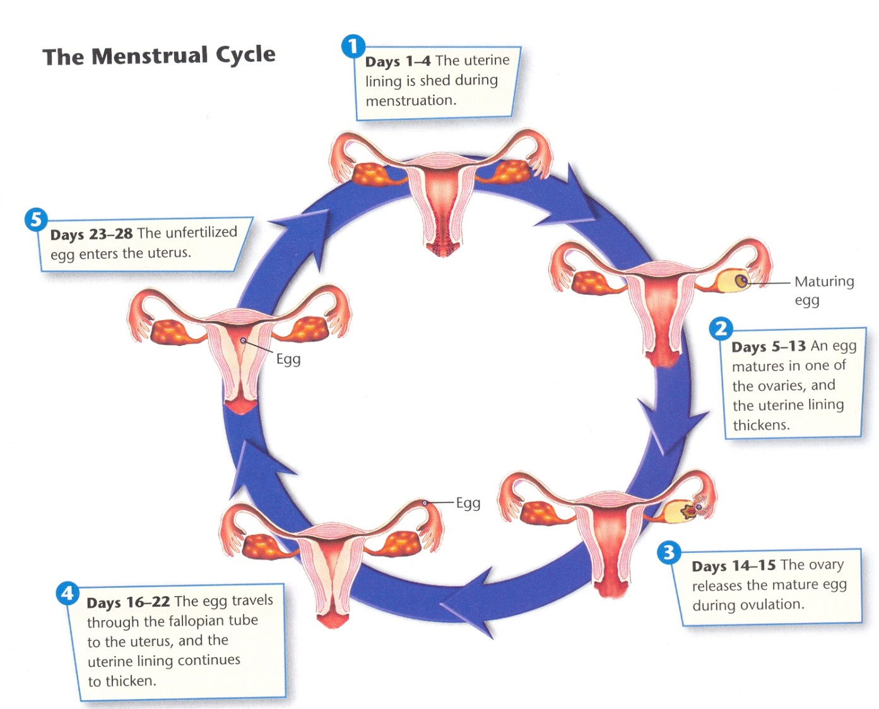

|  |  |
| --- | --- |
| **Days 1-4** | The uterine lining is shed during menstruation. |
| **Days 5-13** | An egg matures in one of the ovaries, and the uterine lining thickens |
| **Days 14-15** |  |
| **Days 16-22** | The egg travels through the fallopian tube to the uterus, and the uterine lining continues to thicken. |
| **Days 23-28** |  |

Caring for the female reproductive system involves the following:

|  |
| --- |
| Cleanliness is important during menstruation as well as daily cleansing  Hygiene sprays, douches and deodorant tampons are not necessary and could be harmful if they cover up signs of infection or cause irritation. |
| Many serious infections can result from sexual contact, practice sexual abstinence |
| Many women experience **vaginitis** an infection caused by yeast, bacteria or microorganisms. (discharge, odors, itching or burning sensation)  A common problem is also **cystitis** a bladder infection, untreated can lead to kidney infections |
| Important to monitor their bodies for possible medical problems.  Symptoms of vaginitis, cystitis, sores or unusual pain see a Dr.  Call Dr. is heavier than normal bleeding or bleeding between periods  Learn how to perform a self-exam  Breast cancer is rare in teens but develop good habits early |
| Yearly checkups are recommended for all females who have reached puberty  Dr. will perform a Pap Smear during the pelvic exam to test for cervical cancer  Starting at age 40 Mammogram  Drs. Can also detect:  **Ovarian Cysts:** growths on the ovary  **Endometriosis**: the tissue from the lining of the uterus grows outside the uterus in the pelvic cavity. Very painful!!  **Infertility** is a condition where you can reproduce possibly due to a blocked fallopian tube(s) or problems with ovulation |

**PREGNANCY**

**TODAY’S GOALS:**

Summarize the events that occur during the first week after fertilization.

Describe the structures that protect and nourish the embryo and fetus.

Identify four behaviors that are essential for a healthy pregnancy.

Explain the importance of prenatal care throughout pregnancy.

Describe the risks associated with teen pregnancy.

**National Standards:**

10.1.12 Evaluate factors that impact growth and development

during adulthood and late adulthood. (Relationships)

**MCj02906790000[1]**

What are some factors you think a married couple should consider before they have a baby?

**PREGNANCY**

|  |  |
| --- | --- |
|  | The united egg and sperm |
|  | Time from the two-cell stage until nine weeks after fertilization. |
|  | A hollow, spherical structure made up of about 50 to 100 cells that attaches to the uterus during implantation. |
|  | Process from which the blastocyst attaches to the uterine wall. |
|  | A fluid filled bag of thin tissue that develops to protect the developing baby. |
|  | Structure that lines the wall of the uterus during pregnancy and nourishes the embryo or fetus with substances from the mother’s blood. |
|  | The cordlike structure that connects the embryo of fetus to the placenta. |
|  | The stage of human development from the third month after fertilization until birth. |
|  | Medical care received during pregnancy. |
|  | A doctor who specializes in pregnancy and childbirth. |
|  | One of the three periods that divides a pregnancy. Each trimester is approximately 3 months. |
|  | High frequency sound waves used to create an image of a developing fetus. |
|  | Condition resulting from the implantation of the blastocyst in a location in the abdomen other than the uterus. |
|  | The death of an embryo or fetus in the first 20 weeks of pregnancy. |

|  |  |
| --- | --- |
|  | Of the hundreds of millions of sperm that enter the vagina during sexual intercourse, only a few hundred make it to the egg, and only one can fertilize it. Within seconds, the surface of the egg changes so that no more sperm can enter the egg. **In the first week after fertilization, the fertilized egg undergoes many cell divisions and travels to the uterus.** |
|  | Within 36 hours, while the zygote is traveling through the fallopian tube, it begins to divide. |
|  | The original cell divides to make two cells, becoming an embryo. As the embryo travels toward the uterus, its cells continue to divide. |
|  | About 5 days after fertilization, the embryo reaches the uterus, where it floats for a few days. |
|  | Once the blastocyst forms, it begins to attach itself ti the wall of the uterus. |

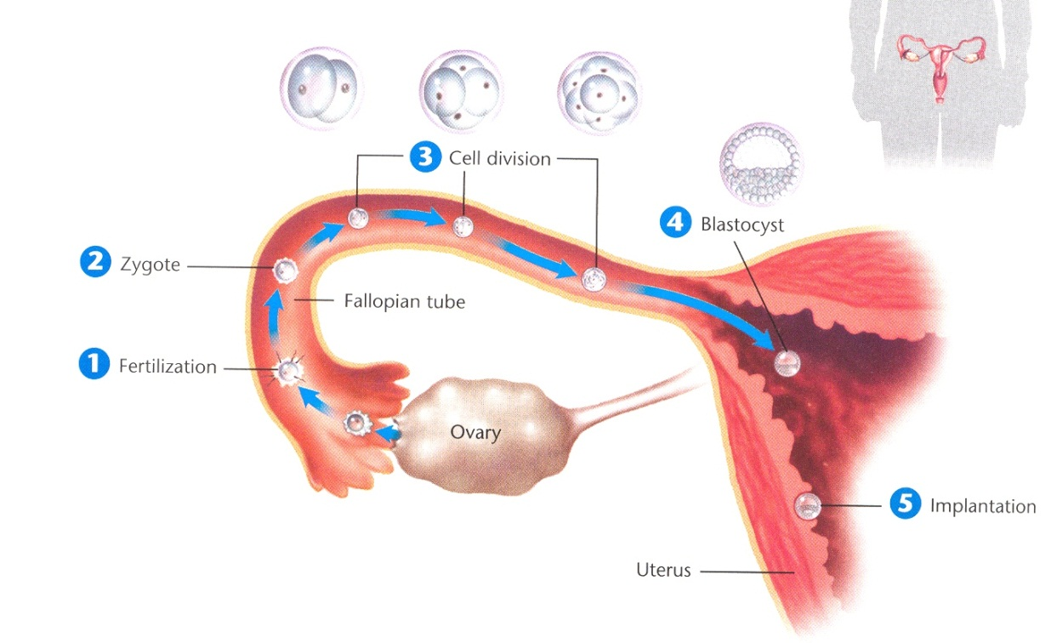

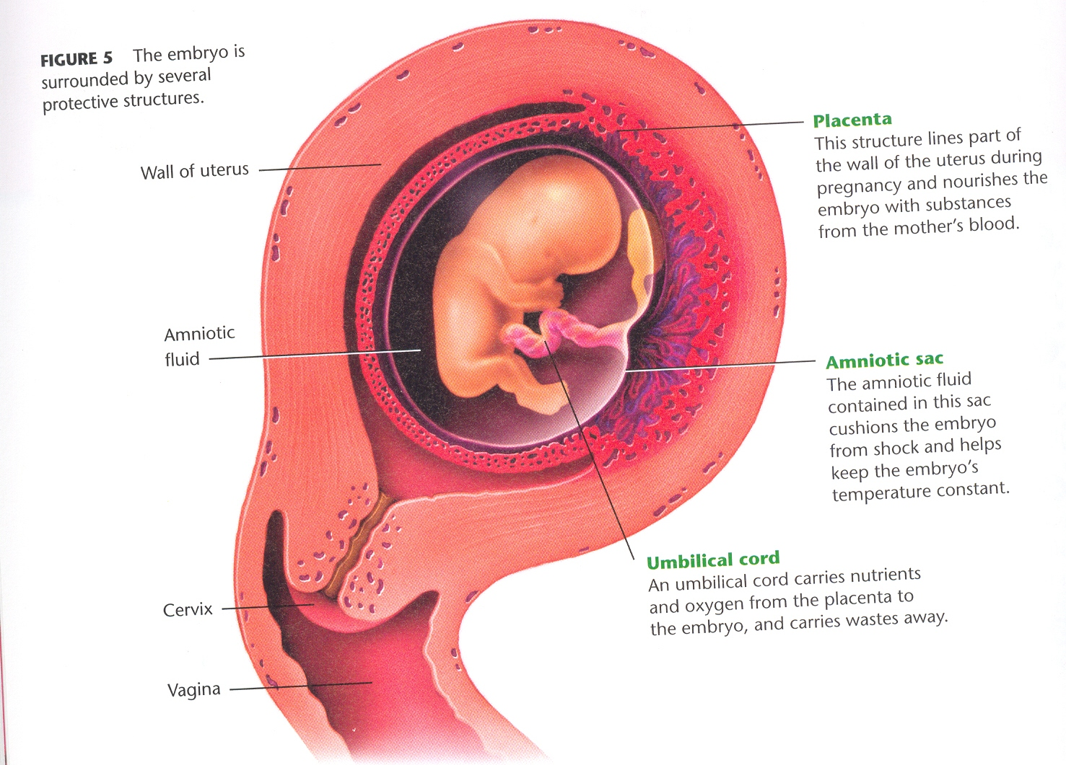

**Getting proper nutrition and exercise and avoiding drugs and environmental hazards are especially important both before and throughout pregnancy.**

|  |  |
| --- | --- |
|  | When you are eating for 2, a pregnant woman needs to eat more calories to support the growth of her own body AND the developing fetus.  Should be consuming about 300 extra calories per day.  Make sure your diet includes all the essential nutrients important for pregnancy, including FOLIC ACID. |
|  | Regular physical activity is important for both the mom AND the baby. This can reduce the risk of gestational diabetes and other health problems. Always get a doctors approval on an exercise routine. |
|  | These substances, even in very small amounts, can harm or potentially kill a developing baby, decrease a newborn’s chance to live, or cause lifelong problems.  Always consult a doctor before taking any medication, including pain medication or cold medication. |
|  | Pregnant women should avoid the following:  X-rays: Both dental and skeletal.  Lead: Lead based paint can be harmful to the fetus.  Mercury: Most exposure to contaminated metal comes from eating contaminated fish. Women should avoid swordfish and shark entirely.  Cat Litter: Cat feces can contain a parasite that is especially dangerous to a developing fetus. |

The chances of having a healthy baby greatly increase when the mother is under the prenatal care of an obstetrician.

|  |  |  |
| --- | --- | --- |
| **_________ TRIMESTER** | **_________TRIMESTER** | **_________ TRIMESTER** |
| -Record medical history and weight.  -Note conditions that could affect the pregnancy.  -_______________________  ________________________ | -Monitor heartbeat of fetus.  -____________________.  -Monitor complications using ultrasound and other tools. | -____________________  _____________________  -Check for warning signs of premature, or early birth.  -Continue to monitor for complications.  -Discuss birth process. |

|  |  |
| --- | --- |
|  | In very rare cases, the blastocyst implants in the fallopian tube or somewhere else in the abdomen. The embryo cannot develop normally and may put the mother’s life at risk. Surgery is necessary. |
|  | The death of an embryo or fetus in the first 20 weeks of pregnancy. Usually occurs in the first trimester. |
|  | High blood pressure during pregnancy that prevents the fetus from receiving the necessary oxygen. Usually treated with bed rest. |
|  | Diabetes in a pregnant woman. Develops later in pregnancy and may cause the fetus to grow too large. |
|  | Delivery of the baby before the 37th week. The earlier the birth, the greater the chance of problems. |

**Health Risks:** Teenagers face risks to their health and to the health of the fetus that most pregnant women in their 20’s and 30’s do not face.

1. Teenagers are still growing and maturing. A teen’s body may not be ready to ______________________________.
2. Many pregnant teens do not follow diets that provide adequate nutrition for both the baby and their growing bodies.
3. Pregnant teens __________________________ to seek early prenatal care.
4. Babies born to ______________________ are more likely to suffer health problems

**In the space below, please describe how your life would be different if you had a baby. Consider how a baby would affect your free time, your friendships, your family relationships, and your goals for the future.**

_______________________________________________________________________________________________________________________________________________________________________________________________________________________________________________________________________________________________________________________________________________________________________________________________________________________________________________________________________________________________________________________________________________________________________________________________________________________________________________________________________________________________________________________________________________________________________________________________________________________________________________________________________________________________________________________________________________________________________________________________________________________________________________________________________________________________________________________________________________________________________________________________________________________________________________________________________________________________________________________________________________________________________________________________________________________________________________________________________________________________________________________________________________________________________________________________________________________________________________________________________________________________________________________________________________________________________________________________________________________________________________________________________________________________________________________________________________________________________________________________________________________________________________________________________________________________________________________________________________________________________________________________________________________________________________________________________________________________________________________________________________________________________________________________________________________________________________________________________________________________________________________________________________________________________________

**PREVENTING PREGNANCY**

**TODAY’S GOALS:**

Explain why abstinence is the only completely effective way to prevent

pregnancy and STI’s.

Explain why contraception is a responsible decision for those who choose to

be sexually active.

Identify the three general types of contraception.

**National Standards:**

10.1.12 Evaluate factors that impact growth and development

during adulthood and late adulthood. (Relationships)

**MCj02906790000[1]**

|  |  |
| --- | --- |
|  | The use of any accepted method to intentionally prevent pregnancy. (birth control) |
|  | The likelihood that using a method of contraception will prevent pregnancy. |
|  | The percentage of women who become pregnant using a particular contraception method during one year’s time. |
|  | A chemical agent that kills sperm. |
|  | The use of surgery or other procedure to make a person permanently incapable of reproduction. |

0

|  |  |  |  |  |
| --- | --- | --- | --- | --- |
| **Contraceptive**  **Methods** | **Failure Rate** | **Protection From STI’s** | **Availability** | **Proper Use** |
| Abstinence | 0% | Complete |  |  |
| Male Condom | 11% | Some |  | Applied immediately before intercourse; used once. |
| Female Condom | 21% | Some |  | Inserted before intercourse,  used once. |
| Diaphragm Plus  Spermicide | 17% | None |  | Must be left in place for 6 hours after intercourse. Can be washed and re-used. |
| Cervical Cap Plus Spermicide | 17-23% | None |  | Proper insertion can be difficult; must be left in place for 8 hours after intercourse. Can be washed and re-used. |
| Shield Plus Spermicide | 15% | None |  | Must be left in place for 8 hours after intercourse. Can be washed and re-used. |
| Sponge | 16% | None |  | Must be left in place for 6 hours after intercourse. Discarded after use. |
| Spermicide Alone | 35% | None |  | Varies based on type. |
| Combination Pill  or Mini Pill | 1 to 2% | None |  | Must be taken daily. |
| Patch | 1 to 2% | None |  | New patch is applied once a week. |
| Ring | 1 to 2% | None |  | New ring is inserted once a month. |
| Injection | <1% | None |  | One injection every 3 months. |
| Permanent Methods | <1% | None |  | One-time procedure.  Tubal Ligation- Female  Vasectomy- Male |

|  |  |  |
| --- | --- | --- |
|  |  |  |
| Prevent sperm from reaching the egg. | Hormonal methods of contraception work by preventing ovulation or inhibiting fertilization. | Should only be used for people who are sure that they do not any children or do not want more children. |
| Male condom, female condom, diaphragm, cervical cap, shield, sponge, spermicides | Oral contraptions, the patch, the pill, rings, and injections | Vasectomy, tubal ligation, and sterilization implant. |

|  |  |
| --- | --- |
| **Periodic Abstinence** |  |
| **Withdrawal** |  |

**On the scale below, show the following contraception methods, comparing their total effectiveness against preventing pregnancy.**

Birth Control Pill Male Condom Sterilization Withdrawal

Diaphragm Female Condom Injections Abstinence

**100% 0%**

**SEXUALLY TRANSMITTED INFECTIONS**

**TODAY’S GOALS:**

Identify the best way to avoid sexually transmitted infections during the teen years.

Identify three of the most common STI’s including their symptoms and treatments.

List four other STI’s and describe their symptoms.

Know when a person should seek treatment for an STI.

**National Standards:**

10.1.12 Evaluate factors that impact growth and development

during adulthood and late adulthood. (Relationships)

**MCj02906790000[1]**

1. What is this song about?
2. List two facts you learned from listening to this song.
3. List two behaviors the singer could have changed to avoid the situation.

|  |  |  |
| --- | --- | --- |
| 1 | A person can have an STI and not know it. |  |
| 2 | It is normal for women to have some vaginal discharge. |  |
| 3 | In this state, parents must be notified before minors can be tested or treated for an STI |  |
| 4 | Once you have had an STI and been cured, you cannot get it again. |  |
| 5 | It is easy to get syphilis or gonorrhea from a toilet seat. |  |
| 6 | It is possible to get crabs, scabies, or yeast infections from borrowed towels and clothing. |  |
| 7 | Women who have sex for the first time before age 20 are at higher risk for cancer of the cervix. |  |
| 8 | A pregnant woman who has an STI can pass the disease on to her baby. |  |
| 9 | STIs that aren’t cured early can make it impossible for a person to have children. |  |
| 10 | Most STIs go away on their own without treatment if people wait long enough. |  |
| 11 | Birth control pills offer excellent protection from STIs. |  |
| 12 | Condoms can help prevent the spread of STIs. |  |
| 13 | Burning with urination is a common symptom of STDs in both men and women. |  |
| 14 | AIDS can be passed from one person to another by hugging. |  |
| 15 | The symptoms of AIDS are the same as the symptoms of other sexually transmitted diseases. |  |

The risky behaviors that account for the current STI epidemic include:

|  |
| --- |
| **___________________________**  Do not take precautions  “It can’t happen to me”!!!! Yes it can!!! |
| **___________________________**  The more sexual partners the greater chance of contracting and STI |
| **___________________________**  Too embarrassed  Do not know they have an STI  No symptoms can only be detected by lab work  Symptoms go away temporarily |

**It can happen to you!**

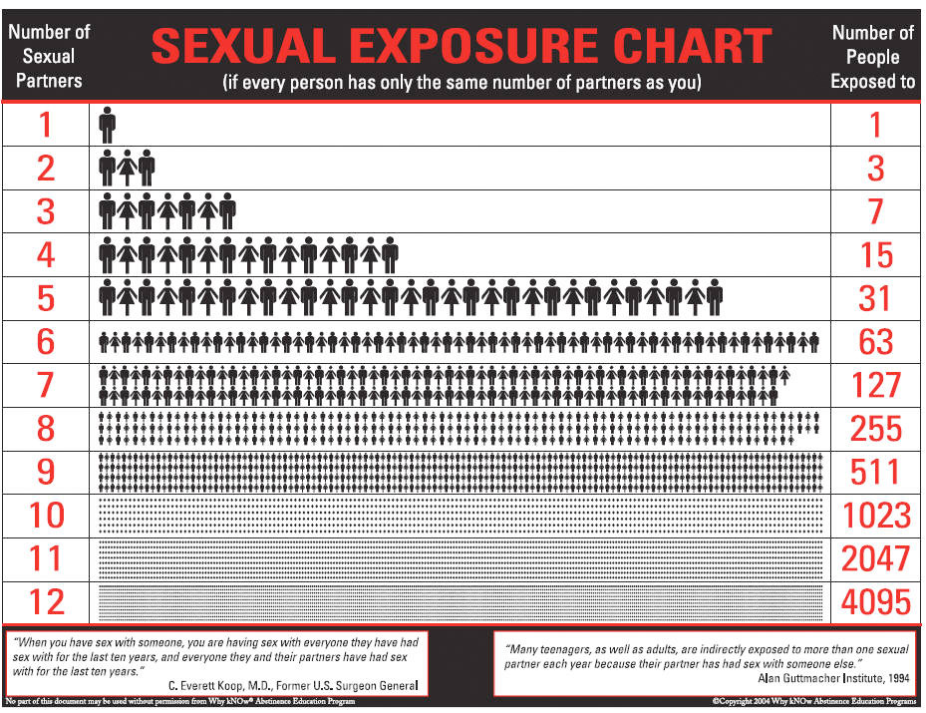

|  |  |  |
| --- | --- | --- |
| Most Common STI’s | | |
|  |  |  |
| -Caused by a protozoan that ______________________  ______________________  **Symptoms**  **In Males**:  Painful urination, a clear discharge from the penis, and some itching.  **In Females:**  Itching or burning in the vagina, an unpleasant smelling, yellowish discharge, and pain when urinating.  -Over 7 million people are infected with Trichomoniasis each year. | -Also known as HPV  -______________________  **Most Common VIRAL STI.**  **Symptoms**  -Causes no symptoms, so people are unaware that they have contracted it.  -Some forms lead to Genital Warts.  -Can itch or burn.  -Can lead to Cervical Cancer  -Pap Tests can help to  prevent this | -**_______________________ caused by BACTERIA in the USA.**  **Symptoms**  **In Males:**  -Painful, frequent urination  -Colorful discharge from the penis  **In Females:**  -Yellowish, vaginal discharge  -Can lead to PID  -Can be cured by antibiotics.  -Infects nearly 13 million people per year. |

|  |  |  |  |
| --- | --- | --- | --- |
| Other STI’s | | | |
|  |  |  |  |
| -Hepatitis B and C  -Infections that attack the liver  -People are often unaware of infection  -**Symptoms**  -Fatigue,  abdominal pain,  nausea, and  jaundice | -Bacterial Infection  -When treated for Chlamydia, also treated for this.  -**Symptoms:**  -Thick pus coming  from penis.  -painful urination  -Can lead to infertility | -Caused by the herpes simplex virus  -One out of every 5 people are infected  -**Symptoms**  -Painful blisters around the mouth or genitals.  -Can be passed from person to person, regardless if there is a blister present. | -Less common than it used to be  -First stage, you get a chance sore  -Second stage, you get sore in mouth and flu-like symptoms  -Third Stage, symptoms disappear but bacteria attacks internal organs.  -Can lead to death. |
| **PUBIC LICE AND SCABIES:**   * Insects and mites that infest in the hair around the genitals * Symptoms include itching around the genitals and a rash. * Can be passed through physical contact, or infested clothing or bedding. * Must use medicated shampoo to treat. | | | |

|  |
| --- |
|  |
|  |
|  |
|  |
|  |

|  |
| --- |
|  |
|  |
|  |

**VII. Conclusion**

Sexually transmitted infections can have far-reaching and sometimes devastating effects on people’s health and relationships. When making decisions about any kind of intimate sexual contact with others, it is important to think about the behaviors that may put people at risk and the possible consequences of those behaviors. We are not necessarily at the mercy of chance when it comes to sexually transmitted infections; we can make choices that will help us stay healthy.

Fast forward into the future you are married. One night you make a poor decision and cheat on your partner. A couple of weeks later you begin to experience symptoms of Chlamydia. You see a doctor, and he confirms your suspicion. You must now tell your partner you are being treated for Chlamydia and that there is a chance they have contracted it as well. What do you say? Consider everything that you may need to include in your explanation. (This should be at least 4 sentences)

________________________________________________________________________________________________________________________________________________________________________________________________________________________________________________________________________________________________________________________________________________________________________________________________________________________________________________________________________________________________________________________________________________________________________________________________________________________________________________________________________________________________________________________________________________________________________________________________________________________________________________________________________________________________________________________________________________________________________________________________________________________________________________________________________________________________________________________________________________________________________________________________________________________________________________________________________________________________________________________________________________________________________________________________________________________________________________________________________________________________________________________________________________________________________________________________________________________________________________________________

**HIV and AIDS**

**TODAY’S GOALS:**

Explain how the HIV infection leads to AIDS.

Describe how HIV is transmitted from person to person.

**National Standards:**

10.1.12 Evaluate factors that impact growth and development

during adulthood and late adulthood. (Relationships)

**MCj02906790000[1]**

Pass It On!

1. How did you feel before and after the activity? Explain
2. What thoughts were going through your head as you were opening the envelope?
3. How can you avoid feeling this way?
4. How can you tell if someone has HIV?

|  |  |
| --- | --- |
| **HIV** | _______________________________________, an incurable sexually transmitted infection that leads to AIDS. |
| **AIDS** | _______________________________________, an often fatal disease of the immune system caused by HIV infection. |
|  | An infection that attacks a person with a weakened immune system. |
| **Asymptomatic Stage** |  |

**HIV attacks Helper T cells. These helper T cells call other cells to help fight any infection. The HIV cells take over the T cells and destroy them while reproducing.**

|  |  |  |
| --- | --- | --- |
| 1 |  | Soon after exposure to HIV, the infected person may feel flu-like symptoms. They will go away after a weeks. There can be many months or years that follow during at which there will be NO SYMPTOMS. They CAN infect others during this time. |
| 2 |  | Symptoms of weight loss, persistent fevers, diarrhea, or fungal infections start to appear. Sometimes cannot appear for 7 to 10 years later. |
| 3 |  | Symptoms become more severe. The body’s ability to fight disease has been weakened by HIV, they are susceptible to infections that a healthy person can easily fight off. One of these infections can lead to death. |

**There are FOUR main ways that HIV can spread from person-to-person.**

1. _____________________
2. _____________________
3. _____________________
4. _____________________

**Testing HIV**

Tests can be done anonymously . If you do test positive for HIV it is important that you contact all previous partners that you have had sex or had shared needles. You should also do follow up testing. People have been given false positive HIV test diagnosis. Even if your results are negative the tests may not register for six months after being infected.

**Treatment**

The main goal of HIV treatment is _______________________________  
  
________________________________. (Viral load low, T cell count High)

A combination drug treatment called “triple drug cocktail” has been the most successful method used in recent years. Three different types of drugs have to be taken each day. They are large pills and there is a lot. They also have to be taken at the same exact time every day or they will the no longer work. HIV will adjust and the person will have to start all over with new stronger treatment. The drugs themselves can make you very sick. It is not sure but people have been living longer healthier lives because of this treatment.

One million people in the United States had HIV infections in the year 2004. Medical costs for a person with HIV may be at least $30,000 per year.

Use this data to estimate the total cost of HIV infections in the United States in 2004.

THEN answer the following question:

With today’s economy, why is HIV prevention such an important issue?

1. Explain how HIV affects the immune system and how it eventually leads to Aids.
2. What is meant by an Opportunistic infection? Give an Example
3. What are four ways that HIV can be transmitted from an infected person to an uninfected person? List Three ways that HIV is not transmitted.
4. Which region of the world accounts for the majority of HIV infections?
5. Should teens in the United States be concerned about the global Aids problem? Why or Why not?
6. HIV is more common in poorer countries than in wealthier countries. Why do you think this might be the case?